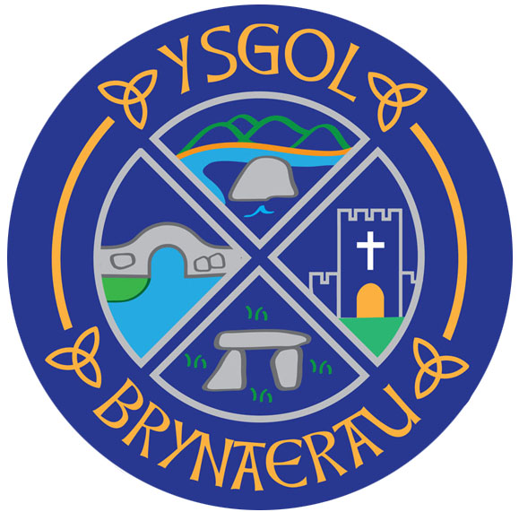
Pontllyfni, Caernarfon, Gwynedd LL54 5EU
 01286 660428
 GlendaEvans@gwynedd.llyw.cymru
http://www.ysgolbrynaerau.co.uk

Pennaeth Mrs Glenda Evans Headteacher

18.09.2020
Annwyl Riant /Ofalwr
Trefniadau’r ysgol pe byddai achos o'r coronafeirws wedi ei gadarnhau yma.

Ysgrifennwn atoch i’ch hysbysu o’r drefn y byddwn yn ei dilyn pe byddai achos o’r coronafeirws wedi ei gadarnhau yn yr ysgol.

Os y bydd yr ysgol yn derbyn cadarnhad o achos coronafeirws yn yr ysgol byddwn yn adnabod pob disgybl sydd wedi rhannu swigen â’r person hwnnw yn unol a chanllaw sydd wedi eu gytuno gan yr Awdurdod Lleol a gwasanaeth Profi Olrhain a Diogelu Gwynedd. Yn ddibynnol ar amgylchiadau unigol, fe all hyn gynnwys swigen ddosbarth, clybiau cyn neu ar ôl ysgol neu rai sydd wedi rhannu cludiant i’r ysgol.

Os y byddwn yn derbyn cadarnhad yn ystod diwrnod ysgol fe fyddwch yn derbyn neges a fydd yn gofyn i chi ddod i nôl eich plentyn o’r ysgol yn syth. Ni fydd caniatâd i’ch plentyn fynd adref ar gludiant ysgol na chludiant cyhoeddus.

Os y byddwn yn derbyn cadarnhad y tu allan i oriau ysgol fe fyddwch yn derbyn neges a fydd yn gofyn i chi gadw eich plentyn adref.

Fe fydd yn ofynnol i'ch plentyn aros gartref, peidio â mynychu’r ysgol, peidio mynd allan i wneud ymarfer corff, peidio ymweld â siopau, teulu na ffrindiau, na mynd i fannau cyhoeddus eraill. Ni ddylech wahodd pobl i'ch tŷ.

Bydd aelod o dîm Profi, Olrhain a Diogelu Gogledd Cymru yn cysylltu â chi maes o law i egluro’r sefyllfa ac i gadarnhau tan bryd fydd rhaid i’ch plentyn ynysu.
Os bydd eich plentyn yn aros yn iach ni fydd angen i aelodau eraill yr aelwyd ynysu a gallant barhau â'u gweithgareddau arferol.

Os nad yw eich plentyn wedi ei adnabod fel rhan o’r swigen cyswllt agos y person sydd wedi profi’n bositif yna bydd disgwyl i’ch plentyn barhau i fynychu’r ysgol.

Gofynnir i holl rieni’r ysgol ddilyn canllawiau’r ysgol yn y mater hwn yn hytrach na dilyn unrhyw wybodaeth answyddogol a rennir ar y cyfryngau cymdeithasol.

Dear Parent / Carer

The school's arrangements if a coronavirus case is confirmed here.

We write to inform you about the procedure that we will follow if a case of coronavirus is confirmed at the school.

If the school receives confirmation of a positive coronavirus case at the school, we will identify each child who shares a bubble with that person in accordance with the guidance agreed by the Local Authority and Gwynedd's Test, Trace and Protect service. Subject to individual circumstances, this could include a class bubble, pre-school or after-school clubs or those who have shared school transport.

If we receive confirmation during the school day, you will receive a message which will ask you to come and pick-up your child from school immediately. Your child will not be permitted to travel home on school transport or public transport.

If we receive confirmation outside school hours, you will receive a message which will ask you to keep your child at home.

It will be mandatory for your child to stay at home, not to attend school, not to exercise outdoors, not to visit shops, family or friends, or to go to other public places. You should not invite people to your house.

A member of the North Wales Test, Trace and Protect team will contact you in due course to explain the situation and to confirm until when your child will need to self-isolate.
If your child remains healthy, other members of the household will not need to isolate and they can continue with their usual activities.

If your child has not been identified as a part of the close contact bubble of the positive person, your child will be expected to continue to attend the school.

All parents at the school are asked to follow the school's guidelines in this respect, rather than follow any unofficial information shared on social media.

Yn gywir

Mrs G Evans

